**Project Design Phase-II**

**Technology Stack (Architecture & Stack)**

|  |  |
| --- | --- |
| Date | 19 October 2022 |
| Team ID | PNT2022TMID02664 |
| Project Name | Smart Waste Management System For Metropolitan Cities |
| Maximum Marks | 4 Marks |

**Technical Architecture:**

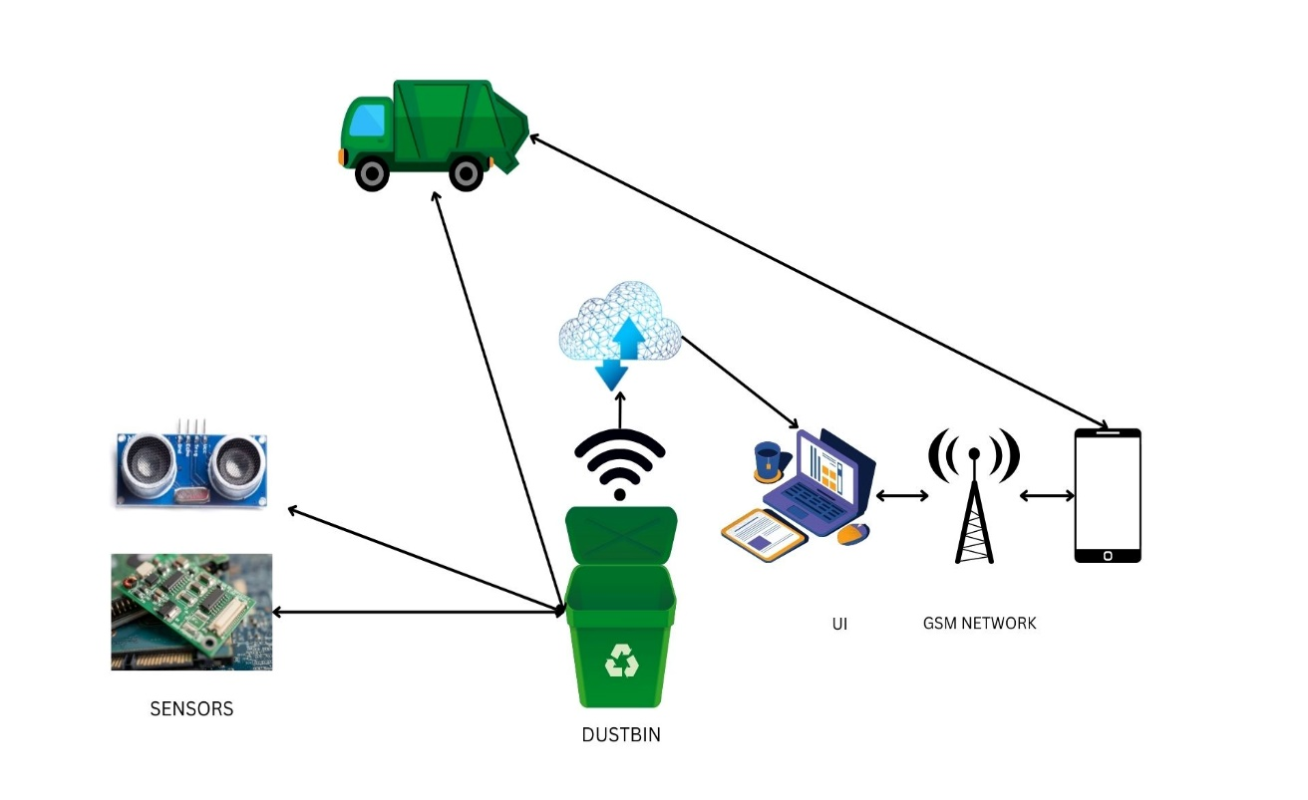

**Table-1 : Components & Technologies:**

|  |  |  |  |
| --- | --- | --- | --- |
| **S.No** | **Component** | **Description** | **Technology** |
|  | User Interface | Web Application | HTML, CSS, JavaScript, React Js |
|  | Application Logic-1 | The information from the weight sensor /load cell is used to calculate the real time weight of the bins and display the same on the web application & to alert the authorities is done using python. | Weight sensor /Load cell  Python |
|  | Application Logic-2 | The information from the ultrasonic sensor is used to display the real time level of the bins in the web application & to alert the authorities is done using python | Level Sensor  Python |
|  | Application Logic-3 | To locate the garbage bins | GPS module |
|  | Cloud Database | Database Service on Cloud | IBM DB2  IBM Cloudant |
|  | File Storage | File storage requirements | Git Hub Repository |
|  | External API-1 | Load cell and level sensors are used to monitor and to give alerts whenever the bins are full | Sensor Technology |
|  | External API-2 |  | Aadhar API, etc. |
|  | Infrastructure (Cloud) | Application Deployment on Local System / Cloud  Local Server Configuration: localhost  Cloud Server Configuration: IBM Configuration | Local, Web application |

**Table-2: Application Characteristics:**

| **S. No.** | **Characteristics** | **Description** | **Technology** |
| --- | --- | --- | --- |
|  | Open-Source Frameworks | IBM Cloud, Python | IoT |
|  | Security Implementations | Role based access control  Provide security at the application level | RBAC  Firewall |
|  | Scalable Architecture | Raspberry pi: Specifications  Soc: rspi ZERO W CPU: 32-bit computer with a 1 GHz ARMv6  RAM: 512MB Networking: Wi-Fi  Bluetooth: Bluetooth 5.0, Bluetooth Low Energy (BLE).  Storage: MicroSD  GPIO: 40-pin GPIO header  Ports: micro HDMI 2.0, 3.5mm analogue audio-video jack, 2x USB 2.0, 2x USB 3.0, Ethernet Dimensions: 88mm x 58mm x 19.5mm, 46g | IoT |
|  | Availability | Load cell and level sensors are used by these smart bins to alert message when the level of bins reaches a threshold and avoid overflowing of bins. | IoT |
|  | Performance | Number of requests: RPI manages to execute 129-139 read requests per second.  Use of Cache:512mb  Use of CDN’s: Real time | IoT |